Version <1.0>

Revision History

|  |  |  |  |
| --- | --- | --- | --- |
| **Date** | **Version** | **Description** | **Author** |
| <dd/mmm/yy> | <1.0> | <details> | Nguyen Kiem Hoa |
|  |  |  |  |
|  |  |  |  |
|  |  |  |  |

Table of Contents

1. Delete Image 4

1.1 Brief Description 4

1.2 Actor 4

2. Flow of Events 4

2.1 Basic Flow 4

3. Special Requirements 4

4. Preconditions 4

5. Postconditions 4

6. Extension Points 4

# Delete Image

## Brief Description

This use case defines the steps of removing an image from the system. User can easily remove an image which they posted.

## Actor

User

# Flow of Events

## Basic Flow

User open the image which they posted and click delete button. Then the image will be remove from database and the user’s gallery with a message ‘Image deleted’.

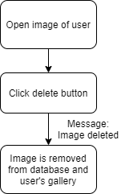

# Special Requirements

Click delete button.

# Preconditions

Image which user posted.

# Postconditions

Image is deleted from database and user’s gallery with a message ‘Image deleted’.

# Extension Points

No extension point.